Recruitment Information

Heritage Officer
November 2014

- Welcome and information on how to apply
- Job Description & Person Specification
- The Theatre Royal in Brief
- How to find the Theatre Royal

[Please save paper – do enjoy reading the following pages, but please only print what you really need. Thank you]
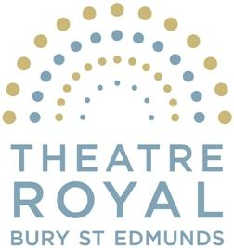
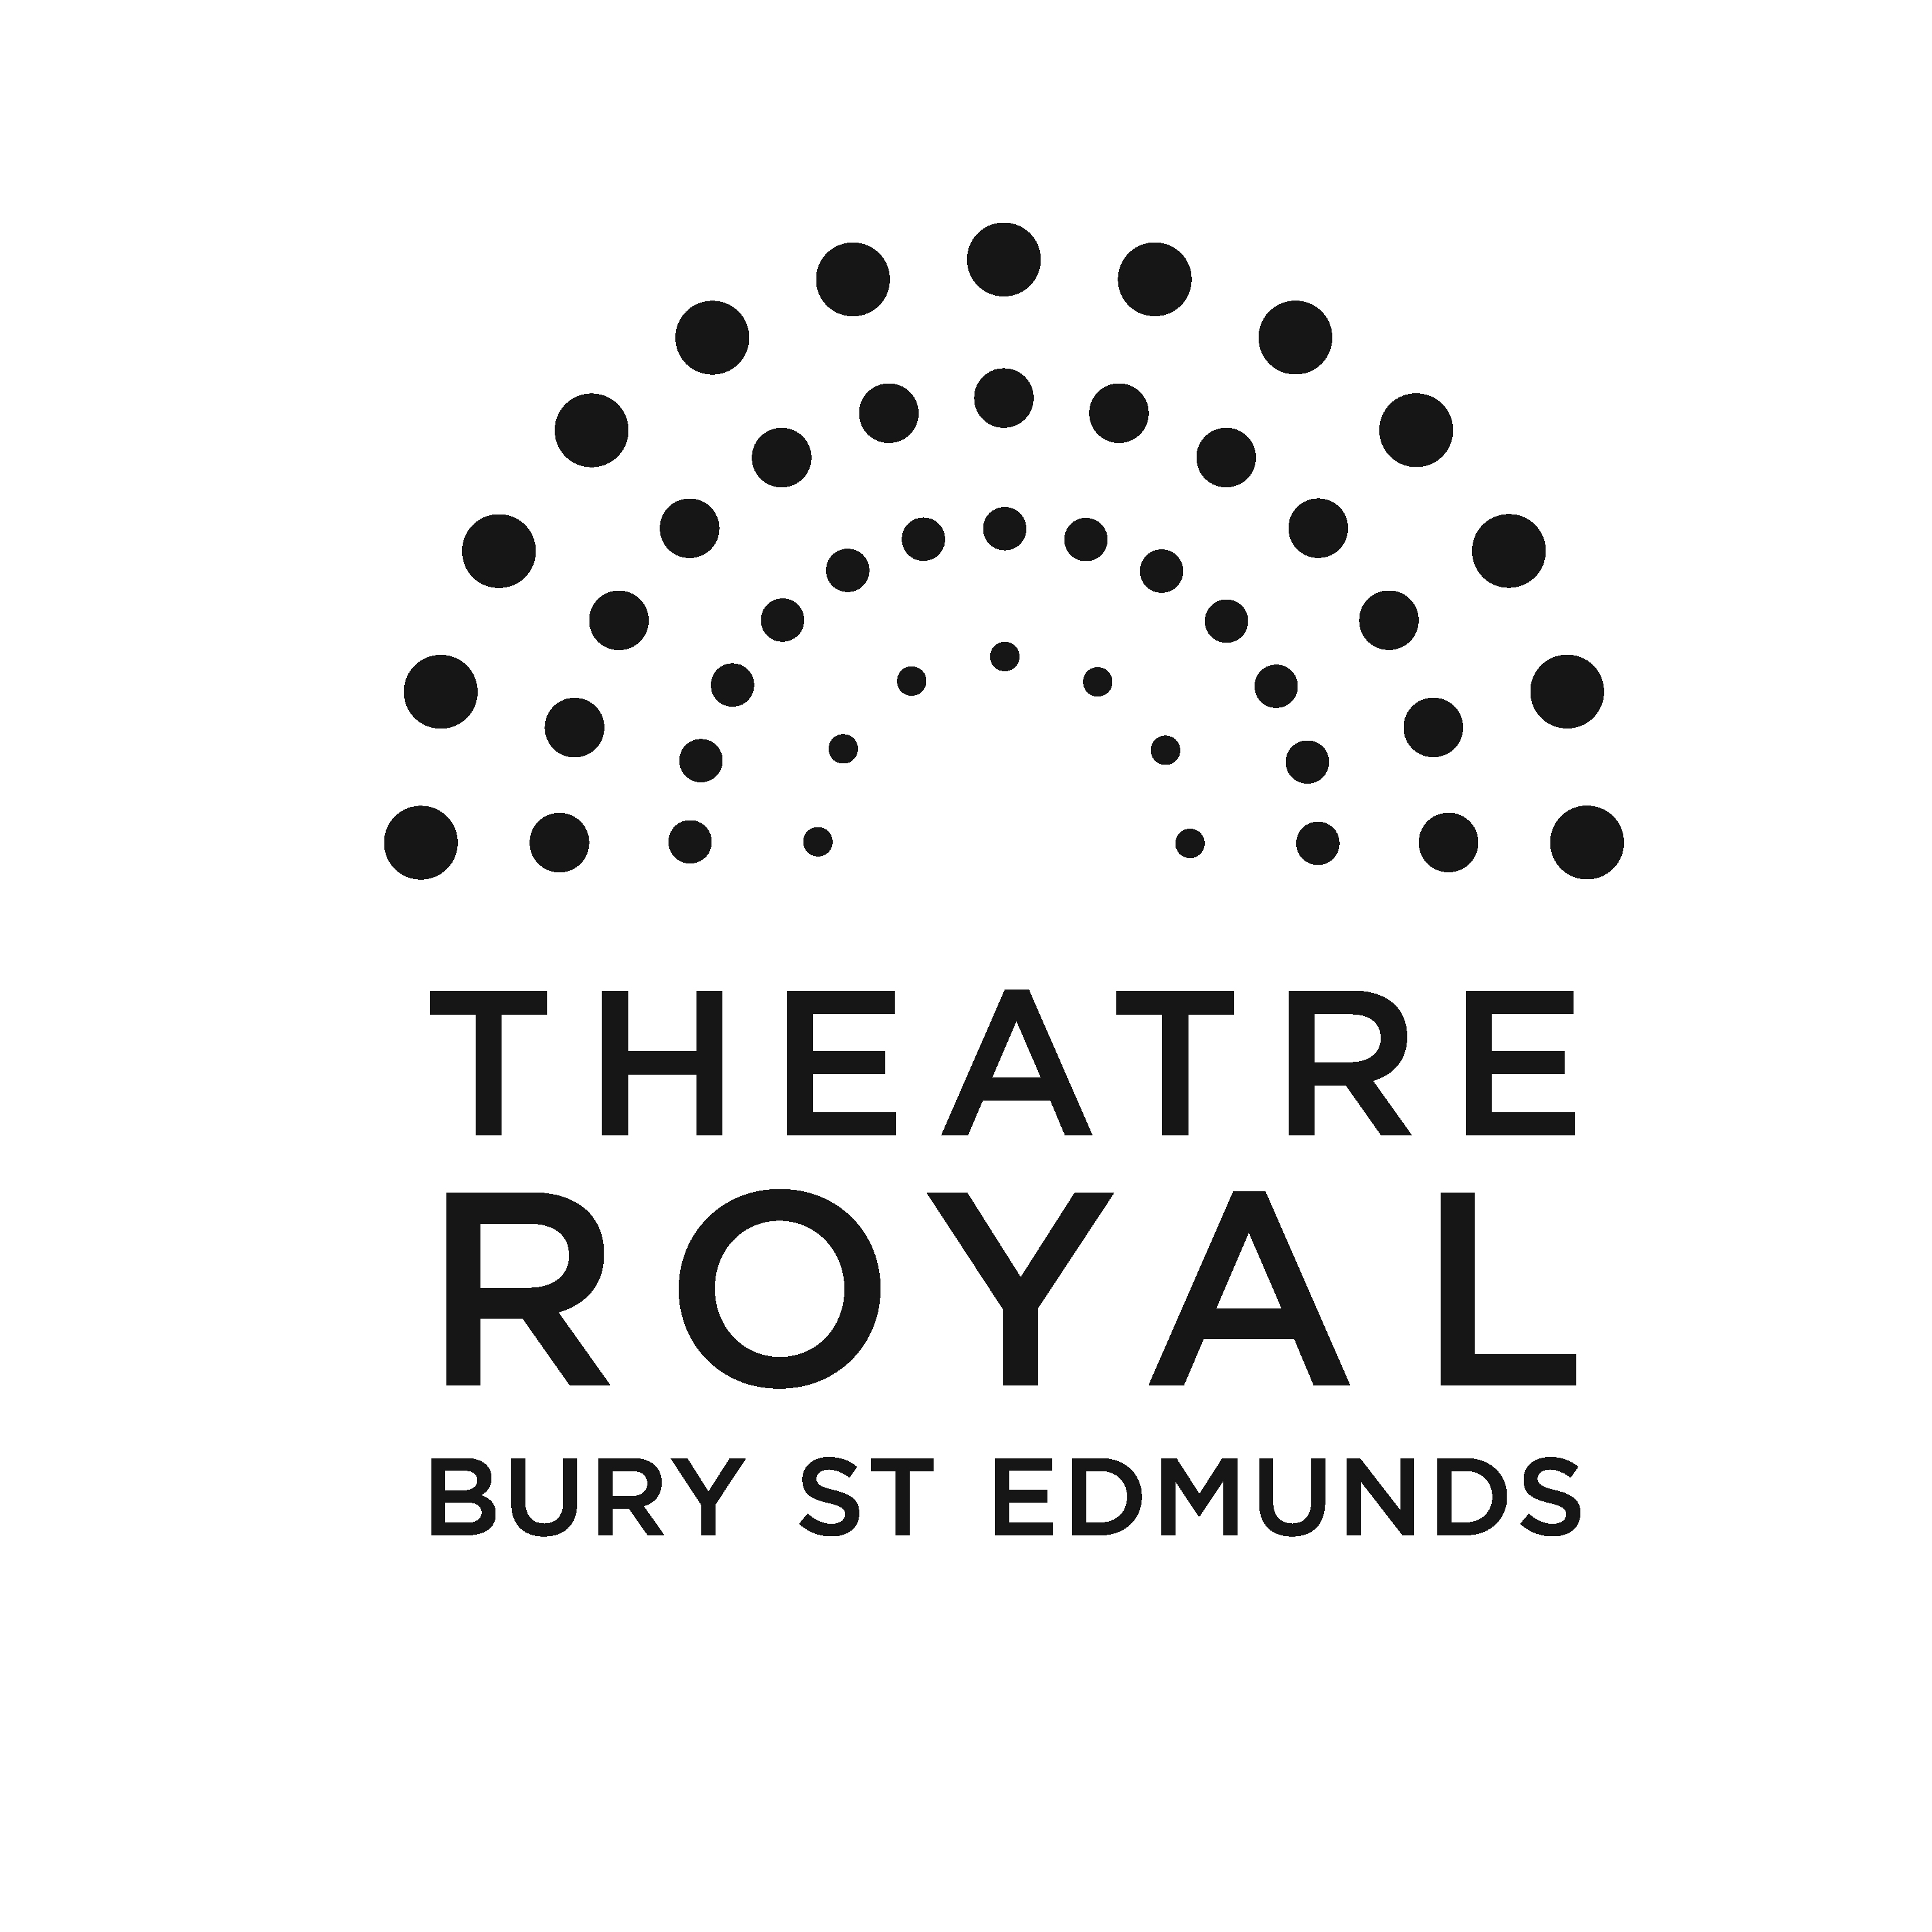

November 2014

Vacancies at the Theatre Royal

Thank you for your interest in joining the staff at the Theatre Royal. Please find enclosed a job description for the post of Heritage Officer and some information about the Theatre Royal which I hope will encourage you to apply to join us. Further information about the Theatre can be found on our website: www.theatreroyal.org

If you would like to be considered for this post, please complete the attached application form and make your application by 12noon, 24th November 2014. It would be helpful if you could also complete the equal opportunities monitoring form. Applications will be accepted by post or e-mail. The application form is available as a Microsoft Word document for you to complete on your computer if you wish, e-mail emma.haley@theatreroyal.org to receive a copy. Please address your application to recruitment at the Theatre Royal, 6 Westgate Street, Bury St Edmunds, Suffolk IP33 1QR.

Good luck and thank you for your interest in working at the Theatre Royal.

Yours Sincerely

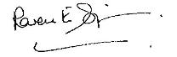

Karen Simpson
Director

Heritage Officer
Job Description

Purpose of post

This post will form part of the team to deliver Theatre Royal’s 50th Anniversary project supported by The Heritage Lottery Fund of the National Lottery.
The role will ensure the delivery of the Heritage components of this project ensuring we successfully engage people at all stages, professionally and as volunteers and participants in accordance with the bid to the Heritage Lottery Fund.
Responsible to: Theatre Royal’s Director and General Manager
Responsible for: The Project Volunteers

This post is based on the equivalent of a 0.2 – 0.4 position depending on experience, starting Dec 2014/Jan 2015 and finishing Dec 2015 and applications are welcome from those engaged or wanting to work in the Heritage sector. Theatre Royal Bury St Edmunds is a Grade 1 listed building and a National Trust property. It is also a fully operational theatre providing a year round programme of drama, music, dance and comedy. For suitably qualified applicants this project is the opportunity to take a lead on a high profile heritage project within a major arts organisation. For applicants with less experience this is a great opportunity to be part of an arts and heritage project, develop key skills and experience and gain greater understanding of practice.

Areas of Responsibility

- Working within agreed objectives to recruit, devise and implement all training for staff and volunteers. This to include:
- Training volunteers and staff in oral history collection
- Training volunteers in transcribing and archiving
Training volunteers in leading tours
- To lead the Volunteer team on this project, providing support and guidance and to administer budgets in relation to their needs.
- To work with the Marketing manager to ensure communication of news and promotion through free media such as regional and employee newsletters, radio and TV, and to maximise the effectiveness of our on-line presence and website.
- To work with project Designers to develop our exhibition materials and printed documents.
- To lead Evaluation processes throughout the project and ensure all targets are met.
- To assist with the organisation of major events throughout the project
- To ensure Theatre Royal volunteers make a video diary of the whole project
- To work with local Archivists to audit what information and artefacts remain from this period and to work with National Trust, Moyses Hall, and Greene King to develop sites for exhibition.
- To work with the Education Project Officer and the Community Projects Officer to ensure all work is recorded and managed to the highest standards.
- To ensure all recordings and transcriptions are given to Suffolk Records Office and the National Library in appropriate formats.
- To undertake any other reasonable duties as requested by Management.

The duties must at all times be carried out with due regard to the Theatre Royal’s Equal Opportunities and Child Protection Policies.

Terms & Conditions

Fee or Salary: £7800
Hours of work: An average of 8-16 hours per week depending on experience. Some evening and weekend work will be required. Time off will be given in lieu of extra hours worked.
Place of work: Whilst not all activities relating to this project will be based at Theatre Royal, it is expected that this post-holder work from an office base within Theatre Royal, Bury St Edmunds and as part of the wider staff team.
Paid Holiday: 5 days paid holiday will be given as part of this contract
Allowances: Travel/mileage expenses whilst on Theatre Royal business
Staff members receive an allocation of complimentary tickets for performances at the Theatre Royal for personal use only.
Pensions: We offer a stake-holder pension provision.
Other information: There is a comprehensive staff handbook and induction plan with detailed information on policies, practices and working arrangements offered to all staff.

Interviews

Applications should be sent to emma.haley@theatreroyal.org no later than 12.00pm Monday 24thNov. Interviews will be the following week on Monday 1st Dec. We will expect the successful candidate to start work on this project as soon as possible.

Selection Criteria

 | Skills | Knowledge & Experience | Demonstrated by
Essential | - Training  - Evaluation Techniques  - Word & Excel  - Research  - Self-Motivation  - Autonomous Working  - Project Planning  - Personable and enthusiastic when talking about the work  - Able to communicate with all spectra of society  - Diplomacy  - The ability to teach and encourage engagement | - Work with the Education sector  - Work with volunteers  - Research techniques involved in Heritage work  - Coordination of a Heritage project  - Delivering on targets  - Evaluation techniques  - Degree-level education or equivalent in life experience | Assessed by  - cv  - covering letter  - short research project prior to interview  - presentation at interview  - questioning at interview
Desirable | - Desktop Publishing  - Passionate about arts, history and/or locality  - Public speaking | - Heritage/history related degree  - Management and recruitment of volunteers  - Interest in Theatre  - The communities of West Suffolk | These should be highlighted in your cv or covering letter, but will not be criteria against which the candidate is judged.

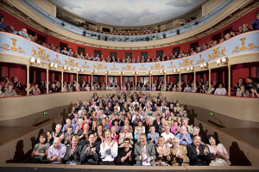
Bury St Edmunds Theatre Management Ltd

The Theatre Royal in Brief

Built in 1819 by the renowned architect William Wilkins (who also designed the National Gallery in London), the Theatre Royal in Bury St Edmunds is one of the most significant theatrical buildings in Europe. As this country’s only example of a playhouse dating from the Regency period, it offers visitors a unique and unforgettable theatrical experience. One of only eight Grade 1 listed theatre buildings in the country, it is also the only working theatre in the National Trust’s entire portfolio of properties. Inspired by its impressive historical pedigree, the Theatre prides itself on the quality and innovation of its artistic work and enjoys a reputation as one of the most forward-thinking arts organisations in the UK.

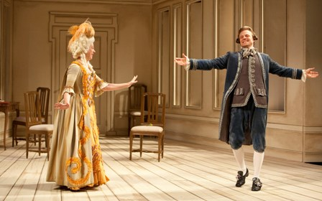
The building is owned by the Greene King Brewery. In 1975, it was leased to the National Trust, which, in turn, has handed the day-to-day running of the Theatre to the Bury St Edmunds Theatre Management Ltd. Like many other theatres of its generation, the Theatre Royal has enjoyed a chequered history, closing and reopening its doors on a number of occasions. The most recent of these, in September 2007, followed a £5.3 million programme of restoration and development. This project, funded in part by the Heritage Lottery Fund, not only returned the building to its 1819 configuration and decoration but also provided improved customer facilities through the creation of a contemporary foyer space adjoining the Theatre.

The Theatre Royal hosted over 300 performances in 2012/13 in the theatre and in other venues. Our work attracts around 65,000 annually, plus over 2,500 young people engage in creative learning activities in schools or in the community. Over 20,000 come to see our renowned annual traditional family pantomime. A further 2,000 people visit for our heritage, either as organised groups year-round or for our BACKSTAGE PAST season, which sees the Theatre as a lively cultural tourism attraction. The Theatre became licensed for weddings and civil partnerships in 2012. A wide range of local community and amateur groups also present performances on the Theatre’s stage and are essential to the cultural offer to the community.
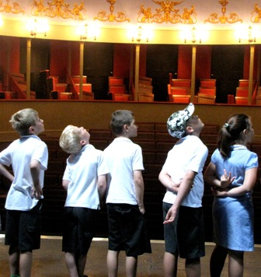
The Theatre Royal celebrates its heritage, and as a National Trust property welcomes visitors to enjoy the restored building through guided tours, talks and lectures, merchandising, as well as rehearsed readings from the Georgian period.
The Theatre employs a paid staff of 20 and supports a number of internships and apprenticeships. It also has a team of approximately 70 volunteers. It is overseen by a non-executive board of management. There is a Patron's Scheme and a thriving Friends scheme numbers over 600 members. The Theatre receives regular grant and project aid from St Edmundsbury Borough Council, Suffolk County Council and Arts Council England (as part of the National Portfolio) and also enjoys strong support from the local business community.

Mission

Theatre Royal Bury St Edmunds presents a high quality programme of performances and creative activities that enrich and inspire children and adults lives.

Aims
- To present a broad performing arts programme of high quality work from leading arts organisations and emerging artists.
- To work within a range of producing models for Theatre Royal productions
- To develop further Theatre Royal as a Creative Learning organisation
- To work within a sustainable business model with a skilled workforce and effective base for our operations
- To develop and grow our audiences
- To build on the trust and support of Theatre Royal’s supporters and stakeholders
- To celebrate Theatre Royal’s unique heritage

During 2014, Theatre Royal started to undergo a major change for its workforce, its community and for the artists it works with. Changes to the Board and the appointment of Karen Simpson as the new Director working alongside Adrian Grady as Interim manger resulted in a refocused, artistically led organization with a commitment to developing a sustainable business model for 2014/15 and a vision to re-engage and develop new audiences.

Vital steps were taken to ensure a speedy move towards implementing this change.

These included:
- An urgent review of the financial systems and assumptions of previous business planning which revealed a significant operational deficit of around £140K per year.
- An examination of the Board and recruitment of new members
- Work with Theatre Royal’s stakeholders to reduce the operational deficit in 2013/14 and to ensure a greater resilience and stability for the future
- An organizational review and creation of a new leaner staffing structure to be in place by March 2014 retaining creative and practical theatre skills alongside an effective customer and management support system
- An examination of its physical resources and new action plan created with Greene King Brewery (the owner of the buildings) and National Trust (who lease the theatre building) to enhance the theatre, develop rehearsal and workshop space at its base, move its base back into the theatre and redesign its office space.
- A new presented programme for Jan – May 2014 developed to reflect the changed priorities offering a strong backbone of drama to re-engage its existing audience and attract new audiences with a particular focus on families and schools
- A new vision integrated vision for Creative Learning within the Artistic programme for 2014/15 led by Theatre Royal’s Director and delivered across the staff and volunteer team.
- An exploration of practical and strategic new ways of working with local and national partners for 2014/15 and beyond
- A cohesive and proactive communications strategy to ensure that the Theatre’s stakeholders.
How to Find the Theatre Royal
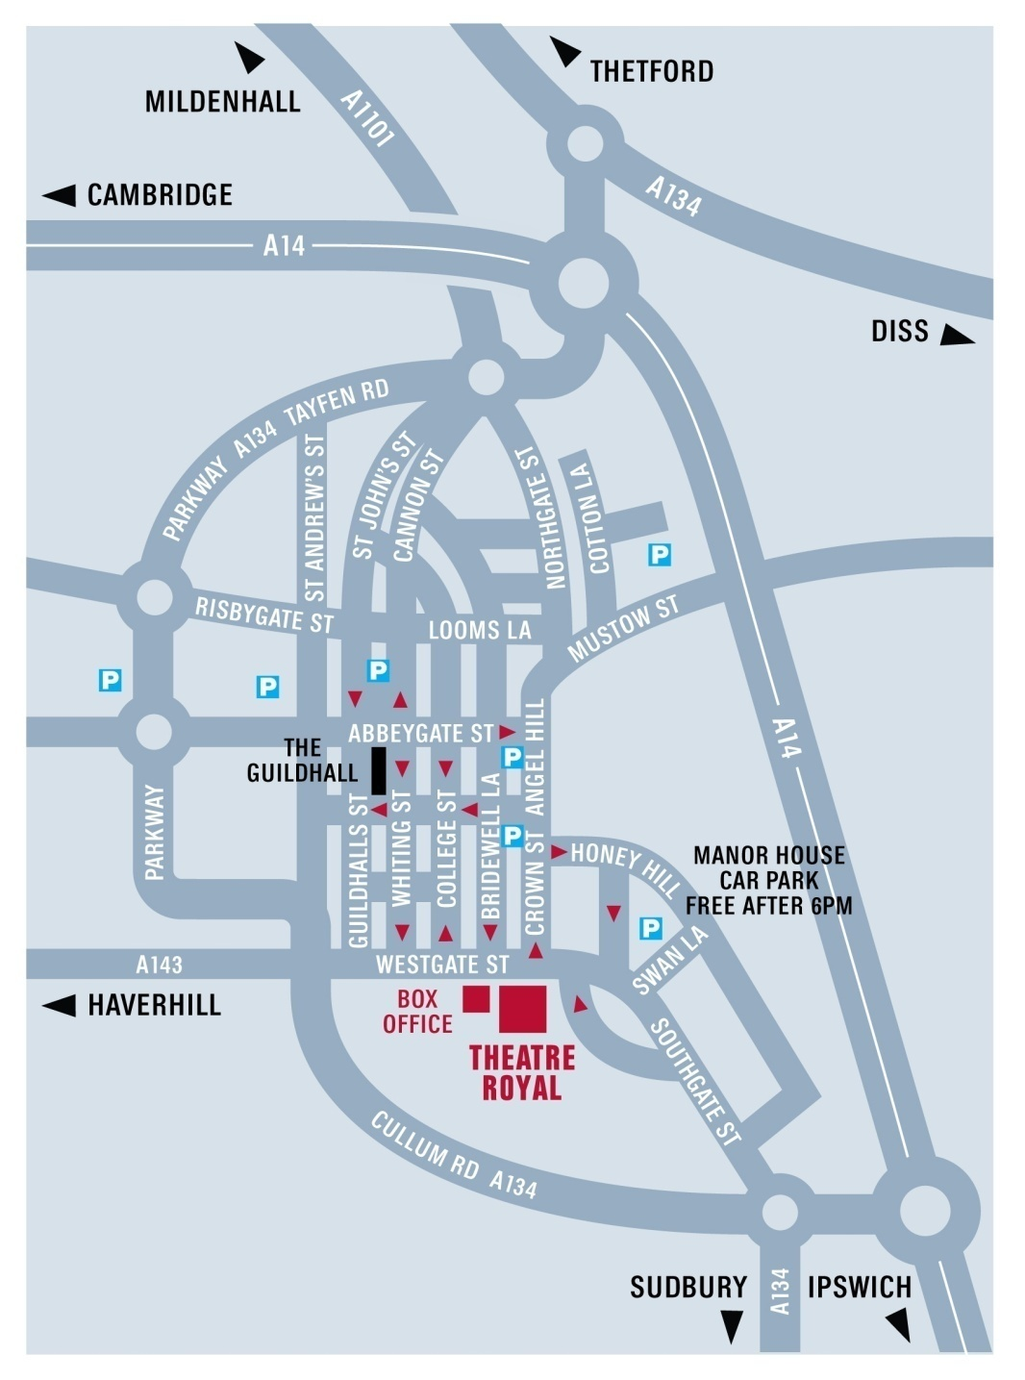

Our offices and Box Office are located at 6 Westgate St next door to the Theatre Royal.  By Road - Bury St Edmunds is just off the A14 east of Cambridge and west of Ipswich. From the Midlands or the East Coast, follow the A14. From London, take the M25 and M11/A11 then A14 heading east (sign-posted Newmarket/Ipswich/Felixstowe). Approaching from the west, take the third exit for Bury St Edmunds and turn right at the big roundabout towards the town centre. Go right at the next roundabout then right at the third roundabout onto Southgate St. Follow the road and you will join the one way system, the Theatre is on your left opposite the Greene King Brewery Museum.  Car-parking is probably the biggest head-ache for first time visitors! There is very limited parking close to the theatre. There are a number of unlimited street parking places on Westgate Street after 6pm. The nearest car-park is at the Manor House Museum.  By Bus - The Bus Station is on St Andrew’s Street North, 10 minutes walk from the theatre. In addition to local services it is serviced by National Express coach connections from all over the country. Enquiries/Reservations: 01284 702020  By Train - Bury St Edmunds Railway Station is on Station Hill and is 20 minutes walk from the theatre, connecting to Cambridge, Ipswich and the London-Norwich line. Enquiries/Reservations: 08457 484950  Taxis  A1 Cars 01284 766777; Premier Cars 01284 704004; United Cars 01284 762288 | Our offices and Box Office are located at 6 Westgate St next door to the Theatre Royal.  By Road - Bury St Edmunds is just off the A14 east of Cambridge and west of Ipswich. From the Midlands or the East Coast, follow the A14. From London, take the M25 and M11/A11 then A14 heading east (sign-posted Newmarket/Ipswich/Felixstowe). Approaching from the west, take the third exit for Bury St Edmunds and turn right at the big roundabout towards the town centre. Go right at the next roundabout then right at the third roundabout onto Southgate St. Follow the road and you will join the one way system, the Theatre is on your left opposite the Greene King Brewery Museum.

Car-parking is probably the biggest head-ache for first time visitors! There is very limited parking close to the theatre. There are a number of unlimited street parking places on Westgate Street after 6pm. The nearest car-park is at the Manor House Museum.

By Bus - The Bus Station is on St Andrew’s Street North, 10 minutes walk from the theatre. In addition to local services it is serviced by National Express coach connections from all over the country. Enquiries/Reservations: 01284 702020

By Train - Bury St Edmunds Railway Station is on Station Hill and is 20 minutes walk from the theatre, connecting to Cambridge, Ipswich and the London-Norwich line. Enquiries/Reservations: 08457 484950

Taxis
A1 Cars 01284 766777; Premier Cars 01284 704004; United Cars 01284 762288

Car-parking is probably the biggest head-ache for first time visitors! There is very limited parking close to the theatre. There are a number of unlimited street parking places on Westgate Street after 6pm. The nearest car-park is at the Manor House Museum.

By Bus - The Bus Station is on St Andrew’s Street North, 10 minutes walk from the theatre. In addition to local services it is serviced by National Express coach connections from all over the country. Enquiries/Reservations: 01284 702020

By Train - Bury St Edmunds Railway Station is on Station Hill and is 20 minutes walk from the theatre, connecting to Cambridge, Ipswich and the London-Norwich line. Enquiries/Reservations: 08457 484950

Taxis
A1 Cars 01284 766777; Premier Cars 01284 704004; United Cars 01284 762288

