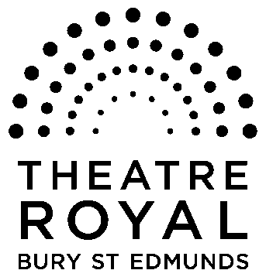**FOR IMMEDIATE RELEASE**

**Media Release**

15 October 2014

Clive Francis Productions

**A Christmas Carol**

By Charles Dickens

**16 November**

**7.30pm**

**One man Dickens masterpiece is the perfect Christmas treat**

**A unique one man adaption of Dickens’ classic novel brings some of literature’s best known characters to life on the Theatre Royal stage.**

Clive Francis reprises his acclaimed RSC performance as Ebenezer Scrooge, the cold-hearted miser who knows nothing about the spirit of Christmas, in *A Christmas Carol* at the Theatre Royal Bury St Edmunds on 16 November.

**‘Spellbinding’ The Sunday Times**

The performance is inspired by Dickens’ first reading and performance of *A Christmas Carol* on 27 December 1853 at Birmingham Town Hall.

Clive Francis brings to life a whole host of Dickensian characters, from the spectral Jacob Marley to the warm and loving Bob Cratchit and his son Tiny Tim, and not forgetting the ghosts of Christmas Past, Present and Future.

**‘Clive Francis’ storytelling is as fresh, ingenious and enthralling as if it had only this minute sprung to life’ The Irish Times**

His film career has included parts in A Clockwork Orange and Inspector Clouseau and TV credits include Yes, Prime Minister, May To December and Poldark.

He has performed this one man *A Christmas Carol* for 12 festive seasons at a variety of venues including theatres, school and churches, and to rave reviews.

In December 2007 he performed it at the Theatre Princesse Grace in Monte Carlo as part of the British Theatre Season in Monaco.

Tickets are £8.50 to 20.50.

**For tickets and further details please call the Box Office on 01284 769505 or visit** [**www.theatreroyal.org**](http://www.theatreroyal.org) **.**

**-Ends-**

**For press enquiries, images, or review tickets, please contact Nicki Dixon, Press and Communications Officer via** [**nicki@theatreroyal.org**](mailto:Nicki@theatreroyal.org) **or 01284 829947.**

**Notes to Editors:**

1. **The Theatre Royal Bury St Edmunds** is the UK’s last surviving working Regency playhouse. Under the care of the National Trust, it is a Grade 1 Listed building, which underwent a £5.3 million restoration in 2005 to return it to its original 1819 layout and design. The Theatre Royal is owned by the Greene King Brewery, leased by the Brewery to the National Trust, which in turn has leased the Theatre to Bury St Edmunds Theatre Management Ltd to run it as a working theatre.