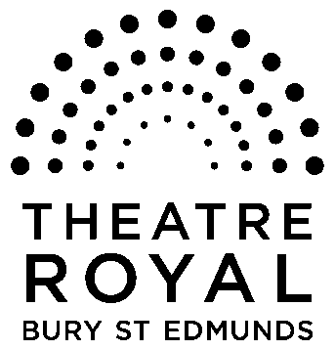**FOR IMMEDIATE RELEASE**

**Media Release**

October 2014

Ballet Theatre UK

**Swan Lake**

**17 to 19 November**

**Romance, sorcery and betrayal – it can only be Swan Lake**

**Tchaikovsky’s *Swan Lake* is one of the most enduring and moving classical ballets and this all new production is presented by Ballet Theatre UK at the Theatre Royal Bury St Edmunds from 17 to 19 November.**

This timeless classic has it all, magic, drama and some of the most popular classical music ever composed.

It tells the tale of a Princess held captive as a swan by the spell of an evil magician, a spell that can only be broken if the Prince swears true love to her.

And Ballet Theatre UK are no strangers to the Theatre Royal, having staged other productions here including *The Little Mermaid*, *The Nutcracker, Cinderella*, *Alice In Wonderland*, *The Snow Queen* and *A Christmas Carol.*

**‘Glittering costumes, expressive dancers….a pleasure to witness a production of this calibre’ Dance Europe, *The Snow Queen***

Celebrating their 10th new production, Ballet Theatre UK will be performing this iconic masterpiece featuring their international cast of highly talented dancers, new glittering costumes and stunning stage sets.

Tickets are £8.50 to £26.

**For tickets and further details please call the Box Office on 01284 769505 or visit** [**www.theatreroyal.org**](http://www.theatreroyal.org) **.**

**-Ends-**

**For press enquiries, images, or review tickets, please contact Nicki Dixon, Press and Communications Officer via** [**nicki@theatreroyal.org**](mailto:Nicki@theatreroyal.org) **or 01284 829947.**

**Notes to Editors:**

1. **The Theatre Royal Bury St Edmunds** is the UK’s last surviving working Regency playhouse. Under the care of the National Trust, it is a Grade 1 Listed building, which underwent a £5.3 million restoration in 2005 to return it to its original 1819 layout and design. The Theatre Royal is owned by the Greene King Brewery, leased by the Brewery to the National Trust, which in turn has leased the Theatre to Bury St Edmunds Theatre Management Ltd to run it as a working theatre.