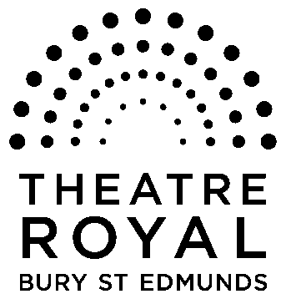**FOR IMMEDIATE RELEASE**

**Media Release**

22 October 2014

# **Theatre Royal Bury St Edmunds celebrates 50th anniversary with Heritage Lottery Fund support!**

Today, Theatre Royal Bury St Edmunds has learnt that it will receive £65,200 from the Heritage Lottery Fund (HLF) for an exciting new project to celebrate the 50th anniversary of the reopening of the Theatre.

Funding will help to tap into local people’s recollections of 1965, when the building was transformed from Greene King’s barrel store to a working community Theatre.

This anniversary project will create an archive of living memories through the collection of stories from the local people and groups who campaigned to reopen it.

A 50th anniversary exhibition at the Theatre will complement a series of talks and tours and the archive collection will be digitalised to be presented online and through social media. This will all be added to the Theatre Royal’s own archive, as well as those belonging to a range of amateur societies, Greene King and other individuals, thus bringing it all together, for the first time, into one unique archive for the future.

School and community groups will also be involved to ensure as many people as possible can share in this story.

All this will inspire a new, high profile play to be presented in the town providing further heritage learning and volunteer opportunities.

Commenting on the award, Director of the Theatre Royal, Karen Simpson, said: “We are thrilled to have received the support of the Heritage Lottery Fund.

“This project will put the Theatre Royal back at the heart of the local community by people engaging with its history and taking ownership of it.

“It is a celebration of the importance of the Theatre within its community and the 50th anniversary is the perfect opportunity to create a dynamic presence in the town.”

Karen also stressed the importance of preserving people’s memories.

“We currently have no recordings of the people who experienced first-hand the reopening of the Theatre Royal in 1965 and the archive material is in a poor state and spread across a range of places.

“If it is not collected now, not only a vital piece of local history but a key part of British Theatre history will be lost for future generations.”

Stuart Hobley, Development Manager at Heritage Lottery Fund said: “This is a story about local people who worked together to save an important heritage site. And now, thanks to Lottery players’ money, we can all share in that local passion for heritage and use it to champion the Theatre Royal for another 50 years

ENDS

## Notes to editors

The Theatre Royal Bury St Edmunds is the country’s last surviving working Regency playhouse. Under the care of the National Trust, it is a Grade I Listed building which underwent a £5.3million restoration in 2005 to return it to its original 1819 layout and design. The Theatre Royal is owned by Greene King Brewery, leased by the Brewery to the National Trust, which in turn has leased it to Bury St Edmunds Theatre Management Ltd to run it as a working theatre.

### About the Heritage Lottery Fund

Using money raised through the National Lottery, the **Heritage Lottery Fund (HLF)** aims to make a lasting difference for heritage, people and communities across the UK and help build a resilient heritage economy. From museums, parks and historic places to archaeology, natural environment and cultural traditions, we invest in every part of our diverse heritage. In the East of England, HLF has awarded more than £400m to over 3,500 projects  [www.hlf.org.uk](http://www.hlf.org.uk).

**For further information, images and interviews, please contact Nicki Dixon, Press and Communications Officer, 01284 829947 or email nicki@theatreroyal.org**

