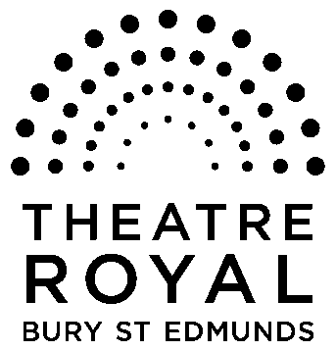**FOR IMMEDIATE RELEASE**

**Media Release**

18 November 2014

**And the winner is…..**

**More than 100 creative children took up the challenge to enter our *Cinderella* panto poster competition.**

And our fabulous *Cinderella* cast took time out of their hectic rehearsal schedule to cast their eyes over all the entries and pick our winner and three runners-up.

Fairy Godmother, Sarah-Louise Young, said: “We were blown away with the variety of entries and the high standard for such young ages.

“It was so hard to make a decision. Congratulations to everyone who entered.”

But a winner they chose and it was seven-year-old Alice Hoxley who attends Guildhall Feoffment School in Bury.

Her dazzling three dimensional homage which had everything Cinderella is loved for including a beautiful, glittering slipper, fabulous dresses, buttons on Buttons, magical Fairy Godmother and a handsome prince.

Her prize is a family ticket to see *Cinderella* and her design immortalised in print to keep forever, as well as her creation featuring in the pantomime programme.

Our runners-up were Rachel Louise O’Driscoll (aged 14) Alice Prosser (aged 7) and Sophie Moss (aged 10).

The runner-up trio get their designs featured in our pantomime programme.

All entries will be on digital display on screens in the Greene Room and anyone wanting to collect their entry can do so from the Theatre Royal Box Office.

**-Ends-**

**For press enquiries, Images or review tickets, please contact Nicki Dixon, Press and Communications Officer via** [**nicki@theatreroyal.org**](mailto:nicki@theatreroyal.org) **or 01284 829947.**

**Notes to Editors:**

The Theatre Royal Bury St Edmunds is the UK’s last surviving working Regency playhouse.

Under the care of the National Trust, it is a Grade I listed building which underwent a £5.3million restoration in 2005 to return it to its original 1819 layout and design.

The Theatre Royal is owned by the Greene King brewery, leased by the Brewery to the National Trust which in turn leased the Theatre to Bury St Edmunds Theatre Management Ltd to run it as a working theatre.