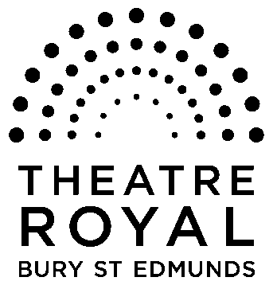**FOR IMMEDIATE RELEASE**

**Media Release**

17 November 2014

**Over 19,000 tickets sold – and counting!**

**Tickets for this year’s Theatre Royal panto *Cinderella* are selling fast – with just over 19,000 already sold.**

And with rehearsals in full swing we have just over a week until opening night on 28 November.

But fear not if you have yet to buy your tickets – you can still go the ball with dates available throughout the run.

Box office staff are on hand to check availability on all dates for anyone who wants to share in the *Cinderella* magic.

Follow Cinders’ journey from her dilapidated family home, Hardup Hall to the splendour of the Prince’s palace.

Meet her outrageous stepsisters, Lady G and Katy P, who really throw a spanner in the works as they too try and win Prince Charming’s heart by trying to make the glass slipper fit.

Directed by Karen Simpson and written by Peter Duncan, *Cinderella* is a traditional family panto with silly jokes, catchy songs and a sprinkling of magic and a must-see festive treat for all ages.

Dates with plenty of tickets still available are: 29 November at 7.30pm, 5 December at 7.30pm, 6 December at 7.30pm, 11 December at 7pm, 2 January at 7.30pm, 3 January at 7.30pm, 6 January at 7pm, 7 January at 7pm, 8 January at 7pm, 9 January at 7.30pm, 10 January at 7.30pm and 11 January at 5pm.

Availability can be checked by calling our Box Office Monday to Saturday 10am to 6pm, or by calling 01284 769505.

Booking can also be done via our website on [www.theatreroyal.org](http://www.theatreroyal.org)

**-Ends-**

**For press enquiries, Images or review tickets, please contact Nicki Dixon, Press and Communications Officer via** [**nicki@theatreroyal.org**](mailto:nicki@theatreroyal.org) **or 01284 829947.**

**Notes to Editors:**

The Theatre Royal Bury St Edmunds is the UK’s last surviving working Regency playhouse.

Under the care of the National Trust, it is a Grade I listed building which underwent a £5.3million restoration in 2005 to return it to its original 1819 layout and design.

The Theatre Royal is owned by the Greene King brewery, leased by the Brewery to the National Trust which in turn leased the Theatre to Bury St Edmunds Theatre Management Ltd to run it as a working theatre.