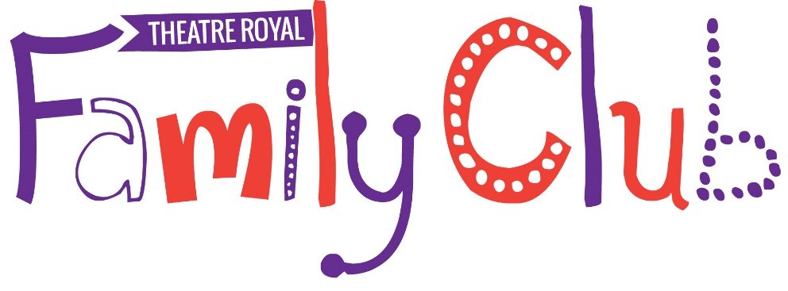

Be a part of it!
Sign up for free today
Fill out the form below and return it to our lovely Box Office staff by either post or email:
booking@theatreroyal.org
Theatre Royal, Westgate Street, Bury St Edmunds, Suffolk, IP33 1QR

Family Name _____________________________________
Number of adults:
Number of children:
Ages of children please list below:
_________________________________________
Address _________________________________________
Postcode ________________________________________
Tel: _____________________________________________
Email: ___________________________________________

By signing up to the Theatre Royal Family Club you automatically agree to be contacted by the methods listed above.

