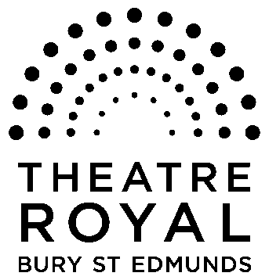**FOR IMMEDIATE RELEASE**

**Media Release**

1 December 2014

Sing-A-Long-A Productions

**Sing-a-long-a-Sound of Music**

www.singalonga.net

**Theatre Royal’s alive with the sound of music**

**It is one of the world’s best loved musicals and the songs are some of the most well known in musical history.**

And what better way to blow the January blues away than to belt out the tunes that made *The Sound of Music* so iconic?

*Sing-a-Long-A Sound of Music* (16 January)will be celebrating the film’s 50th anniversary with a birthday party to remember by showing the film, starring Julie Andrews and Christopher Plummer, with subtitles so there’s no excuse not to join in!

From *Climb Every Mountain* and *Edelweiss* to *Doe-a-Deer* and *The Lonely Goatherd*, *Sing-A-Long-A-Sound of Music* is a fun night out for all ages.

Dress up and join us for a night in Salzburg and the mountains of Austria and make the Theatre come alive with the *Sound of Music*.

Tickets from £8.50 to £16.50.

**For tickets and further details please call the Box Office on 01284 769505 or visit** [**www.theatreroyal.org**](http://www.theatreroyal.org)

**-Ends-**

**For press enquiries, Images or review tickets, please contact Nicki Dixon, Press and Communications Officer via** [**nicki@theatreroyal.org**](mailto:nicki@theatreroyal.org) **or 01284 829947.**

**Notes to Editors:**

The Theatre Royal Bury St Edmunds is the UK’s last surviving working Regency playhouse.

Under the care of the National Trust, it is a Grade I listed building which underwent a £5.3million restoration in 2005 to return it to its original 1819 layout and design.

The Theatre Royal is owned by the Greene King brewery, leased by the Brewery to the National Trust which in turn leased the Theatre to Bury St Edmunds Theatre Management Ltd to run it as a working theatre.