CREATIVE EMPLOYMENT PROGRAMME
EMPLOYER DETAILS
Organisation | Theatre Royal  Bury St Edmunds | Business Type | Producing & Touring Theatre
Address | Westgate Street  Bury St Edmunds | Postcode | IP33 1QR
Contact Name | Natalie Sinnadurai | Job title | Production & Programming Administrator
Telephone No | 01284 829944 | Email Address | natalie@theatreroyal.org
VACANCY DETAILS
Job Title | Marketing & Communications Assistant | Type of job | Paid Internship:  18 to 24 years old
Duration of job | six months | Location of job | Theatre Royal  Bury St Edmunds
Hours (weekly) | 30 hours per week | Salary (hourly) | National Minimum Wage
Number of vacancies | one
Required Start Date | May 2016
Recruitment process detail | Apply by application form.  At the time of applying candidates must be aged between 18 and 24 years, inclusive, and be registered as unemployed with Job Centre Plus.  Closing date for applications: 12 noon, Monday, 9 May 2016  Interviews: week commencing 16 May 2016
PAID INTERNSHIP JOB SPECIFICATION
Role Description | Work in all aspects of marketing and communications, providing administrative and organisational support.  Duties will include:  - Distributing print and displays in town  - Assisting with writing and distributing press releases  - Compiling theatre listings for media.  - Assisting with preparing e-newsletters, flyers and direct mail  - Use of social media  - Collating and filing press cuttings
Person Specification | Essential characteristics  - An interest in the arts and event management  - Good personal, written and verbal communication skills  - A good understanding of social media  - Copywriting skills  - Be able to work to deadlines  - Good organisational skills  - An ability to work independently as well as part of a team  Desirable characteristics  - An interest in and awareness of regional media  - The ability to drive and have access to a car  - Educated to A level standard or equivalent.

Please read all the pages of this document before completing your application. Once completed return to natalie@theatreroyal.org or via post to Natalie Sinnadurai, Theatre Royal, Westgate Street, Bury St Edmunds, Suffolk, IP33 1QR by 12 noon, Monday, 9 May 2016.
Position Applied for | Marketing & Communications Assistant Internship

1 Personal Details

Surname
Forename(s)
Address | Postcode
Telephone (day)
Telephone (evening)
Email address
National Insurance No.

2 Why are you applying for this post?

3 What can you offer us?
Please include details of any relevant skills, experience and knowledge (there are later sections for information about training and education)

4 Present or most recent employment/experience of work

Name and address of organisation | Postcode
Position held
Salary (if applicable)
Date appointed
Date left appointment and why (if applicable)

Outline briefly your duties and responsibilities
5 Previous appointments/experience of work

Name and address of organisation | Position held and dates | Main duties and responsibilities | Reason for leaving
6 Training and education
Include details of exams passed, courses attended and qualifications obtained

7 What else are you interested in?
eg leisure activities

8 Additional Information

Do you need a permit to work in the United Kingdom? YES / NO

Do you have any condition or disability which may affect your ability to do the job, and/or require us to make reasonable adjustments? YES / NO

If Yes please give details including any adjustments that you may need to be made both in respect of the job and the interview

9 Transport
Some positions at the Theatre Royal require employees to drive, if this is applicable to the position you are applying for, please complete this section

Do you hold a current, clean driving licence? YES / NO
Do you have access to a car? YES / NO
If the answer to either of these questions is No, please explain how you would meet the travel requirements of the post (where applicable)

10 Confidential Declaration of Criminal Record

Some positions at the Theatre Royal require employees to be responsible for young people aged under 18 and vulnerable adults, if this is applicable to the position you are applying for, you are required to disclose details of any criminal record. Only relevant convictions and other information will be taken into account so disclosure need not necessarily be a bar to obtaining this position. All information submitted will be kept strictly confidential.

Have you ever been convicted by the courts or cautioned, reprimanded or given a final warning by the police? YES / NO

If Yes please give details of offences, penalties and dates

Are you aware of any police enquiries undertaken following allegations made against you, which may have a bearing on your suitability for this post?
YES / NO

If Yes please give details of offences, penalties and dates

Have you undertaken a Criminal Record Bureau enhanced disclosure for any previous employment? YES / NO

If Yes please give the date your last check was done

Please note that all posts that involve working with young people aged under 18 and vulnerable adults at the Theatre Royal are exempted from the Rehabilitation of Offenders Act 1974, which means that all convictions, cautions, reprimands and final warnings on your criminal record need to be disclosed.

11 References

Please supply details of two persons (other than relatives) from whom references can be obtained. If you have had previous employment one of your referees should be your current or most recent employer.

Name  Address  e-mail  Daytime telephone number  Occupation  Employer/Personal Referee  delete as appropriate | Name  Address  e-mail  Daytime telephone number  Occupation  Employer/Personal Referee  delete as appropriate

Are you willing for references to be contacted prior to interview? YES / NO

12 Declaration

I confirm that the information I have given on this form is correct and complete to the best of my knowledge, and that misleading statements may be sufficient for cancelling any agreements made.

I understand that, if the position I am applying for is responsible for young people aged under 18 and vulnerable adults, I will be required to complete a Criminal Records Bureau enhanced disclosure if appointed.

Signed
Date

Theatre Royal Bury St Edmunds
Equal Opportunities Monitoring

The Theatre Royal is committed to a policy of equality of opportunity in all aspects of its recruitment and employment procedures. All candidates will receive fair and equal consideration.

In order for us to put this commitment into practice we need to assess how well our recruitment procedures operate in practice and it would be helpful if you would answer the questions below and return this sheet with your application form. There is no obligation for you to complete the form.

The information submitted will be treated in the strictest confidence and will be used only for statistical monitoring. It is not part of the selection process and will be separated from the application prior to short-listing.

Position Applied for | Marketing & Communications Assistant Internship
Year of Birth
Gender

Please circle or highlight your ethnic origin

Asian/Asian British |  | Black/Black British
Chinese |  | Middle/Near Eastern
Mixed Ethnic Group |  | White/White European
Other (please describe)

Do you consider yourself to have a disability? YES / NO

How did you become aware of this vacancy?
please tick as many as are applicable and delete where necessary

Publication | Type of advert
Arts Professional | Online / Printed magazine
The Stage | Online / Printed paper
Theatre Royal Website
Stage Jobs Pro
Arts Jobs
Other Internet Site
Other source (please specify)

Please return your completed forms to Natalie Sinnadurai
by 12 noon on Monday, 9 May 2016

Bury St Edmunds Theatre Royal Management Limited
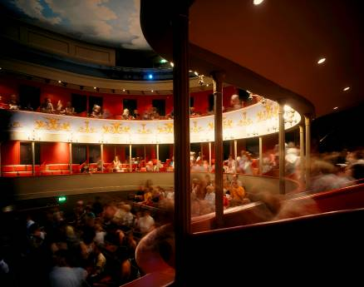
The Theatre Royal Built in 1819 by the renowned architect
William Wilkins (who also designed the National Gallery in London), the Theatre Royal in Bury St Edmunds is one of the most significant theatrical buildings in Europe. As this country’s only example of a playhouse dating from the Regency period, it offers visitors a unique and unforgettable theatrical experience. One of eight Grade 1 listed theatre buildings in the country, it is also the only working theatre in the National Trust’s entire portfolio of properties. Inspired by its impressive historical pedigree, the Theatre prides itself on the quality and innovation of its artistic work and enjoys a reputation as one of the most forward-thinking arts organisations in the UK.

The building is owned by the Greene King Brewery. In 1975, it was leased to the National Trust which, in turn, has handed the day-to-day running of the Theatre to Bury St Edmunds Theatre Management Limited. Like many other theatres of its generation, the Theatre Royal has enjoyed a chequered history, closing and reopening its doors on a number of occasions. The most recent of these, in September 2007, followed a £5.3 million programme of restoration and development. This project, funded in part by the Heritage Lottery Fund, not only returned the building to its 1819 configuration and decoration but also provided improved customer facilities through the creation of a contemporary foyer space adjoining the Theatre.

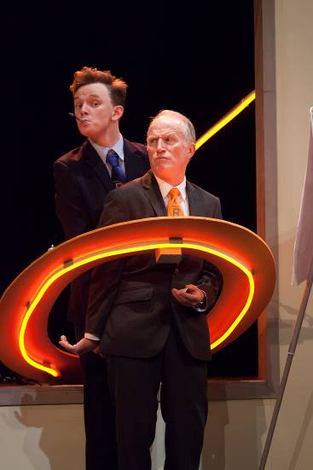
Our work attracts around 75,000 visitors a year, plus over 2,500 young people engage in creative learning activities in schools or in the community. Over 20,000 come to see our renowned annual traditional family pantomime. A further 2,000 people visit for our heritage, either as organised groups year-round or for our Open Doors. The Theatre became licensed for weddings and civil partnerships in 2012. A wide range of local community and amateur groups regularly present performances on the Theatre’s stage and are essential to the cultural offer to the community.

The Theatre Royal celebrates its heritage and, as a National Trust property, welcomes visitors to enjoy the restored building through guided tours, talks and lectures. The Theatre employs a paid staff of 30 and supports a number of internships and apprenticeships. It also has a team of approximately 70 volunteers. It is overseen by a non-executive board of management. There is a Patron's Scheme and a thriving Friends scheme numbering over 600 members. The Theatre receives regular grant and project aid from St Edmundsbury Borough Council, Suffolk County Council and Arts Council England (through project grants) and also enjoys strong support from the local business community.

Mission

Theatre Royal Bury St Edmunds presents a high quality programme of performances and creative activities that enrich and inspire children and adults lives.

Aims
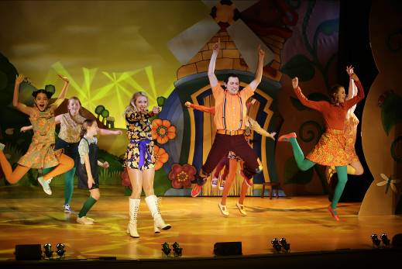
- To present a broad performing arts programme of high quality work from leading arts organisations and emerging artists.
- To work within a range of producing models for Theatre Royal productions.
- To develop further the Theatre Royal as a Creative Learning organisation.
- To work within a sustainable business model with a skilled workforce and effective base for its operations
- To develop and grow audiences.
- To build on the trust and support of Theatre Royal’s supporters and stakeholders.
- To celebrate the Theatre Royal’s unique heritage.

How to get to the Theatre Royal
Report to the Box Office at the Theatre Royal.

By Road: Bury St Edmunds is just off the A14 east of Cambridge and west of Ipswich. From the Midlands or the East Coast, follow the A14. From London, take the M25 and M11/A11 then A14 heading east (sign-posted Newmarket/Ipswich/Felixstowe). Approaching from the west, take the third exit for Bury St Edmunds and turn right at the big roundabout towards the town centre. Go right at the next roundabout then right at the third roundabout onto Southgate Street. Follow the road and you will join the one way system, the Theatre is on your left opposite the Greene King Brewery Museum.
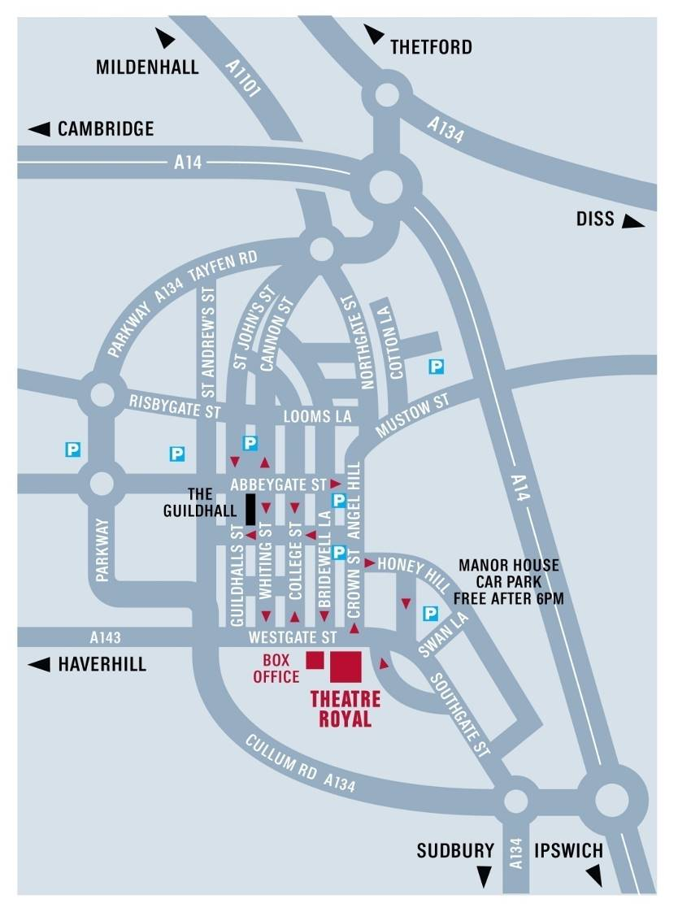
Car parking is probably the biggest headache for first time visitors! There is very limited parking close to the Theatre. There are a number of unlimited street parking places on Westgate Street after 6.00 pm.

By Bus: The Bus Station is on St Andrew’s Street North, 10 minutes’ walk from the Theatre. In addition to local services it is serviced by National Express coach connections from all over the country.

Enquiries/Reservations: 01284 702020

By Train: Bury St Edmunds Railway Station is on Station Hill and is 20 minutes’ walk from the Theatre, connecting to Cambridge, Ipswich and the London to Norwich line. Enquiries/Reservations: 08457 484950

Taxis:

A1 Cars 01284 766777; Premier Cars 01284 704004; United Cars 01284 762288

